Project Design Phase-II
Data Flow Diagram & User Stories

Date | 22 February 2026
Team ID | LTVIP2026TMIDS42033
Project Name | Weather-Based Prediction of Wind Turbine Energy Output: A Next-Generation Approach to Renewable Energy Management
Maximum Marks | 4 Marks

Data Flow Diagrams:
A Data Flow Diagram (DFD) is a traditional visual representation of the information flows within a system. A neat and clear DFD can depict the right amount of the system requirement graphically. It shows how data enters and leaves the system, what changes the information, and where data is stored.
Example: (simplified)
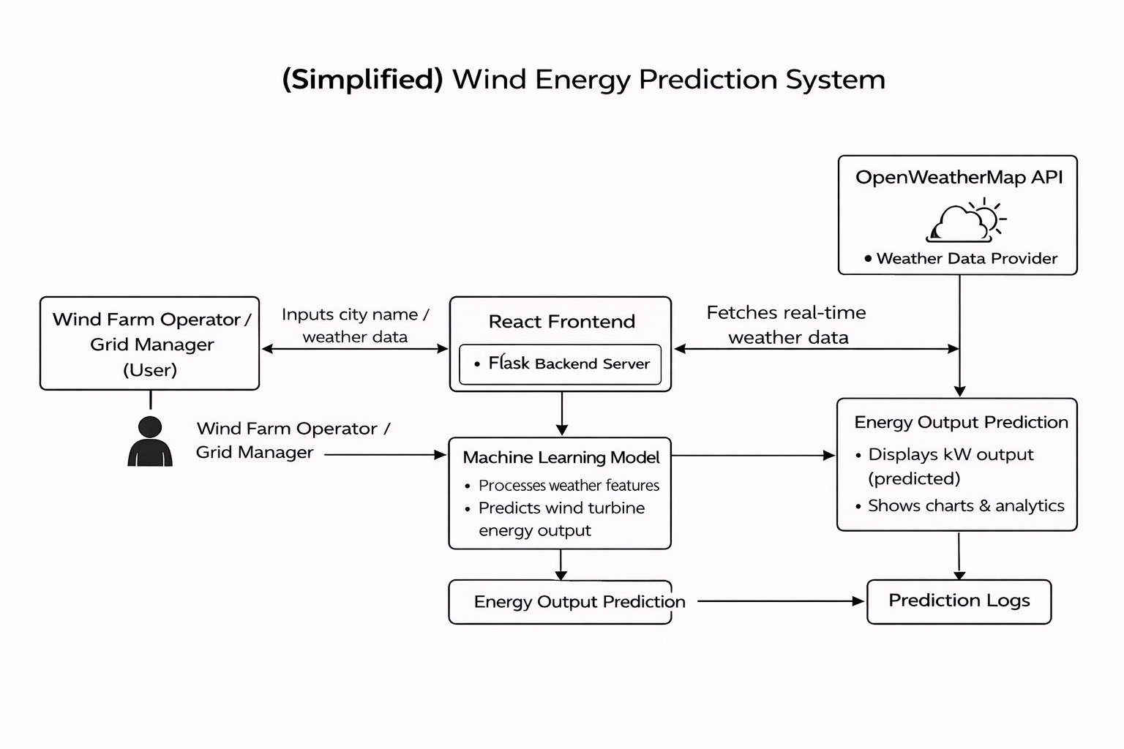
Example: DFD Level 0 (Industry Standard)
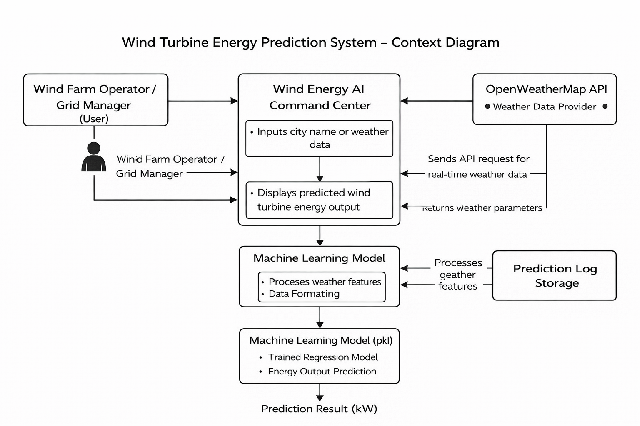

User Stories
User Type | Functional Requirement | USN | User Story | Acceptance Criteria | Priority | Release
Wind Farm Operator | Weather Search | USN-1 | As a user, I can enter a city name to fetch real-time weather data | Weather data displayed correctly | High | Sprint-1
Wind Farm Operator | Energy Prediction | USN-2 | As a user, I can predict wind turbine energy output based on weather data | Predicted output shown in kW | High | Sprint-1
Wind Farm Operator | Visualization | USN-3 | As a user, I can see energy output in charts and gauge format | Chart and gauge display correctly | High | Sprint-2
Grid Manager | Wind Direction | USN-4 | As a user, I can view wind direction for grid balancing decisions | Wind direction displayed correctly | Medium | Sprint-2
Admin | Model Management | USN-5 | As an admin, I can retrain the ML model with updated dataset | Model retrained successfully | Medium | Sprint-3

